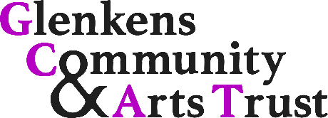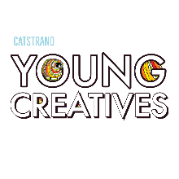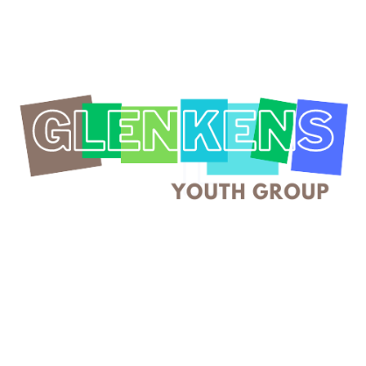

Safeguarding for Children and Young People:
Code of Conduct for Youth Group participants.
It’s really important to us that everyone can attend and enjoy GCAT Youth Groups like CatStrand Young Creatives and the Glenkens Youth Group without feeling uncomfortable or unwelcome. We therefore ask everyone who attends any of their events or activities to abide by this Code of Conduct.

Younger children: Parents and Carers, please summarise the aims of this Code for your child in an age-appropriate way. Thank you!

These are our guiding principles:

- Respect for Others: Treat all attendees (children, young people and adults) with respect and kindness. Listen attentively to others and avoid interrupting or speaking over others.

- Inclusivity: Embrace diversity and be inclusive of all participants, regardless of their race, ethnicity, gender, sexual orientation, religion, or disability. Respect others' differences and refrain from comments that could be hurtful. We have a zero-tolerance approach to bullying and active discrimination, including cyber-bullying.

- Active Participation: Engage actively in the workshops, events, and activities. Participate in discussions, offer ideas, and contribute to group activities to the best of your abilities. You’ll enjoy it more that way!

- Safety: Follow all safety instructions provided by the workshop facilitators and staff. Use any tools or equipment responsibly and with caution, reporting any potential hazards or issues immediately.

- Personal Belongings: Take responsibility for your personal belongings during events and activities. Keep your belongings secure and do not touch or use other participants' belongings without their permission.

- Respect for Space: Treat our venues and equipment with respect. Do not damage any property or equipment, and leave the space clean and tidy after each session.

- Cooperation and Collaboration: Work cooperatively with other participants and practitioners. Respect others' ideas and opinions, and be willing to collaborate and share responsibilities.

- Confidentiality: Respect the privacy and confidentiality of others. Do not share personal information or confidential discussions without permission – do not gossip and do not talk about people behind their backs, either in person or online.

- Responsible Use of Technology: If technology is used during workshops or activities, use it responsibly and for the intended purpose only. If asked to not use phones during an activity or event, please respect that.

- Online interaction: Respect others' boundaries regarding the use of technology. Be as pleasant in your online communications as you are in real life, and remember that images or text put online exist forever.
We have a zero-tolerance approach to cyberbullying or harmful online behaviour. This includes, but is not limited to:

- Creating or using online groups to discuss another person in their absence.
- Sharing images of a person without their consent.
- Sending hostile or unpleasant messages to another person.
- Sending repeated unsolicited messages to another person when asked to stop.
- Commenting unpleasantly on public or private posts.

- Open and Honest Communication: If you have any concerns or issues during the events or activities, communicate openly and honestly with the workshop facilitators or staff. They are here to support you.

Remember, sticking to this Code of Conduct allows everyone to have a safe and enjoyable experience during Catstrand Young Creatives and Glenkens Youth Group events and activities. Repeated or serious breaches of this code may result in temporary or permanent exclusion from events or activities and we will have to let your parents or carers know why.

Created: February 2022
Last review: July 2023
Next review: July 2024

